Summer Camps

June 8-12 Big Bows In A Candy Store 9:30-12:30 Ages 5-8 $125

June 15-19 Summer Dance Intensive 9:00-1:00 Ages 6 and up $200

June 22-26 Frozen Fun 9:30-12:30 Ages 4-8 $125
10:00-11:00 Ages 2-3 $65

June 22-26 Rotten To The Core-Descendants 6:00-8:00 Ages 6-10 $80

June 29-July 3 Beautiful Ballerina 9:30-12:30 Ages 4-8 $125
10:00-11:00 Ages 2-3 $65

July 6-10 Under The Sea 9:30-12:30 Ages 4-8 $125
10:00-11:00 Ages 2-3 $65

July 13-17 Summer Dance Intensive 9:00-1:00 Ages 6 and up $200

July 20-24 Hair Up (Trolls) 6:00-8:00 Ages 6-10 $80

July 20-24 Enchanted Unicorns and 9:30-12:30 Ages 4-8 $125
Glitter Rainbows
10:00-11:30 Ages 2-3 $65

July 27-31 Magical Princess 9:30-12:30 Ages 4-8 $125
10:00-11:00 Ages 2-3 $65

One Day Theme Camps
Ages 4-8 9:30-12:30
$25 per day
($20 when you sign up for 2 or more)

June 10th Mickey and Minnie
June 17th Peppa Pig
June 24th Paw Patrol
July 1st Pinkalicious
July 8th Daniel Tiger
July 16th Superhero
July 22nd Fancy Nancy

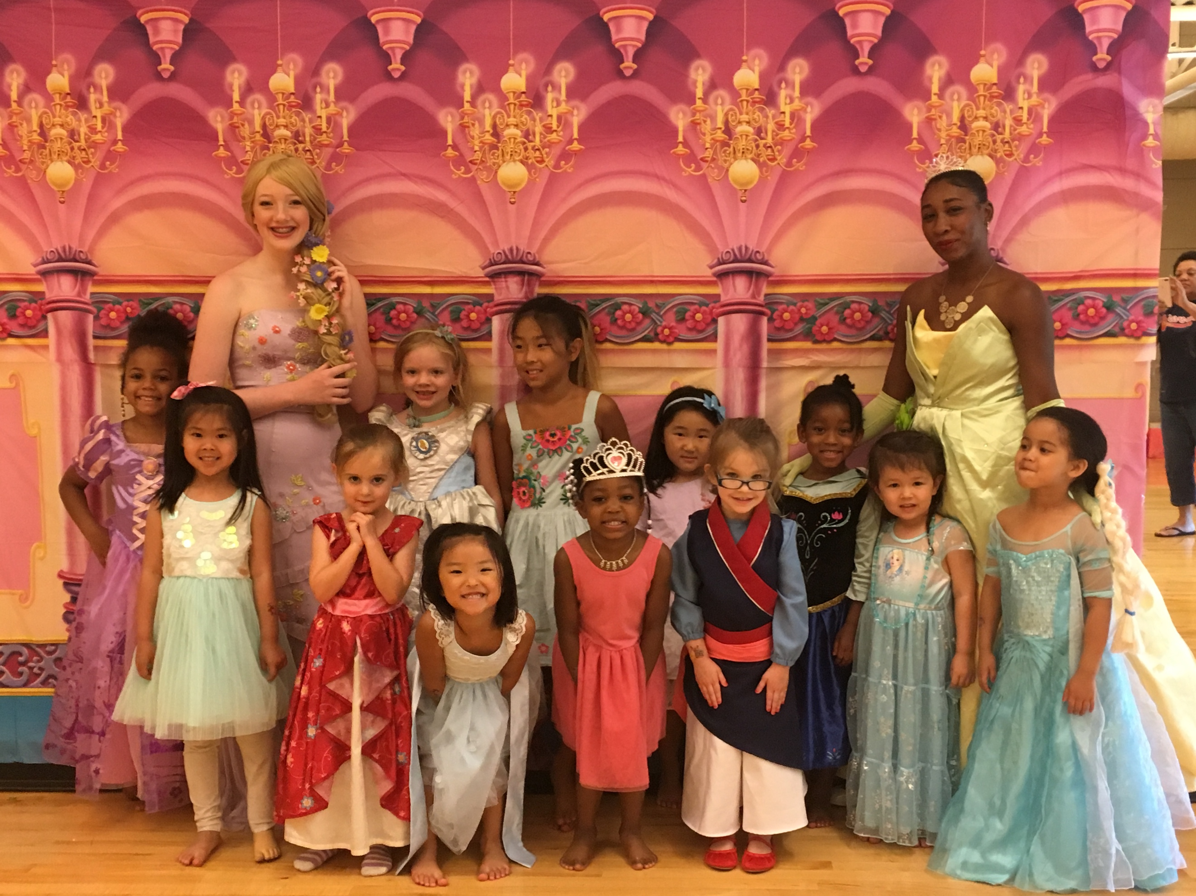
2020 Summer Classes
June 9th- July 23rd
(no classes June 29-July 3)

Tuesdays:
Studio One
5:30-6:15 Tumbling 8 & up
6:15-7:15 Turns/Leaps/Jumps 8 & up
7:15-8:00 Musical Theater Ages 11& up
8:00-9:00 Jazz/Lyrical Technique Ages 11& up

Studio Two:
4:30-5:15 Tutus/Tap/Tumbling Ages 3-5
5:15-6:00 Hip Hop/Tumbling Ages 3-5
6:00-7:00 Ballet/Tap/Jazz Ages 6-10
7:00-7:45 Hip Hop 1 Ages 6-10

Thursdays:
Studio One
5:00-5:45 Strength/Conditioning Ages 6 & up
6:00-7:30 Guest Class Ages 6-10
7:30-9:00 Guest Class Ages 11& up

Studio Two:
5:00-5:45 Fairytale Ballet Ages 3-5
5:45-6:15 Tiny Ballerinas Age 2

Prices:
30 minute class - $10
45 minute class - $12
60 minute class - $15
Guest classes- $25

We know that everyone is busy during the summer with fun vacations and activities that is why our summer classes are pay as you go! No need to sign up for all 6 weeks just stop in and take a class or two when you can.

